IMPACT TRAINING PROJECT USING DSA WITH PYTHON
MOVIE TICKET BOOKING SYSTEM

Introduction
The Movie Booking System is a Python-based web application designed to simulate an online movie ticket booking platform, allowing users to register, log in, browse movies, book seats, and manage reservations.

Problem Domain
Managing movie ticket bookings manually can be inefficient, error-prone, and time-consuming. It is challenging to track available seats, user preferences, and reservations effectively without an automated system.

Solution Domain
This system automates the booking process using Python classes and in-memory data structures, enabling efficient seat management, user authentication, and movie browsing. Users can interact with a simple web interface for seamless operations.

Requirements
- DSA Implemented:
  - Array/Matrix: For seat layout and availability checks.
  - Dictionary: For efficient storage and retrieval of users and movies.
  - Search Algorithm: Used in the movie search functionality.
- Software Used:
  - Programming Language: DSA With Python
  - Frameworks: Flask for web application development.
  - Styling: HTML, CSS, and FontAwesome for UI design.
  - IDE/Editor: Python-compatible IDE VS Code

Methodology used
The methodology employed in this project revolves around Object-Oriented Programming (OOP) and modular design principles with a focus on in-memory data management. Here's a breakdown:

1. Object-Oriented Design
- Classes and Objects:
  - User, UserManager,Movie, MovieBookingSystem, and MovieManager classes encapsulate the core functionalities:
    - User: Handles user data like name, email, and password.
    - UserManager: handles signup, signin ,authenticate password & email.
    - Movie: Manages individual movie details and seat availability.
    - MovieBookingSystem: Integrates user and movie management.
    - MovieManager: Handles preloaded movie data and operations like booking, searching, and fetching movie details.
- Encapsulation:
Each class encapsulates its data and methods, ensuring modular and reusable code.
- Abstraction:
The complex logic for seat booking, user management, and movie handling is abstracted within methods, making the system easier to understand and maintain.

2. In-Memory Data Management
- Data Structures:
  - Dictionaries are used for quick lookup of users and movies.
  - 2D Arrays (Lists) represent seat layouts for each movie.
  - Lists handle collections of preloaded movies.
- Advantages of In-Memory Approach:
  - Fast and efficient for small-scale applications.
  - Simplifies development without requiring external databases.

3. Modular and Layered Approach
- Separation of Concerns:
  - User-related functionalities are managed in the UserManager.
  - Movie operations (like booking and searching) are handled in the MovieManager and Movie classes.
  - MovieBookingSystem acts as the central hub to coordinate user and movie operations.
- Reusability:
Each module (class) is designed independently, allowing for future scalability.

4. Algorithms and Logic
- Search Algorithm:
  - Linear search is used in the search_movies function to filter movies based on the query.
- Seat Booking Logic:
  - A nested loop iterates over a 2D list to find and book the first available seat.

5. Interactive Frontend Integration
- The methodology includes the integration of a Flask web framework to provide a user-friendly interface, enabling interaction with the backend through RESTful routes.
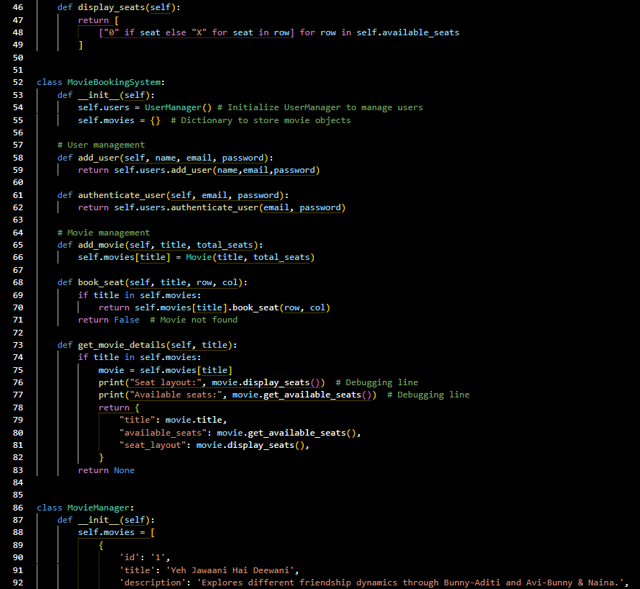

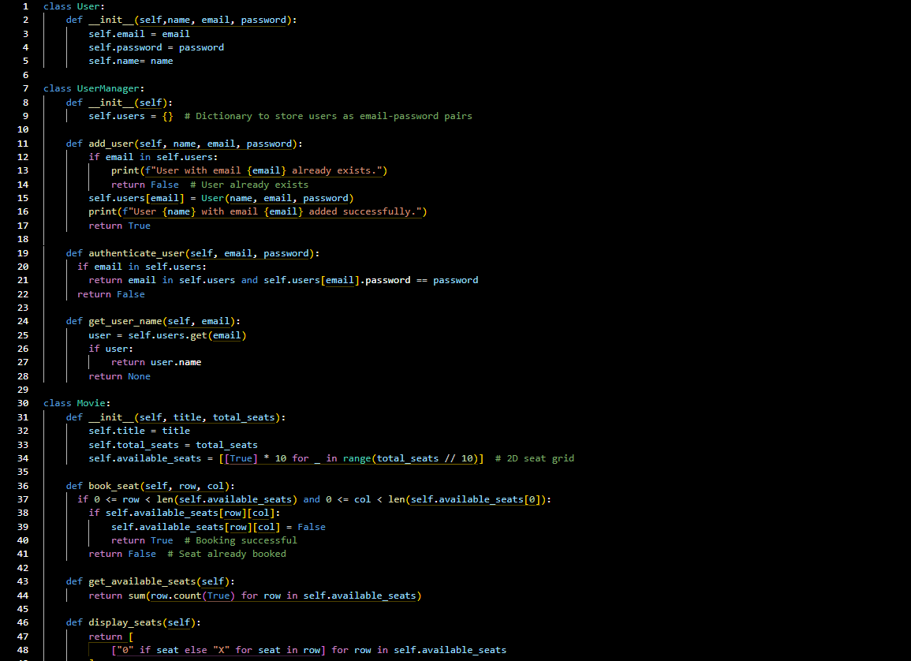
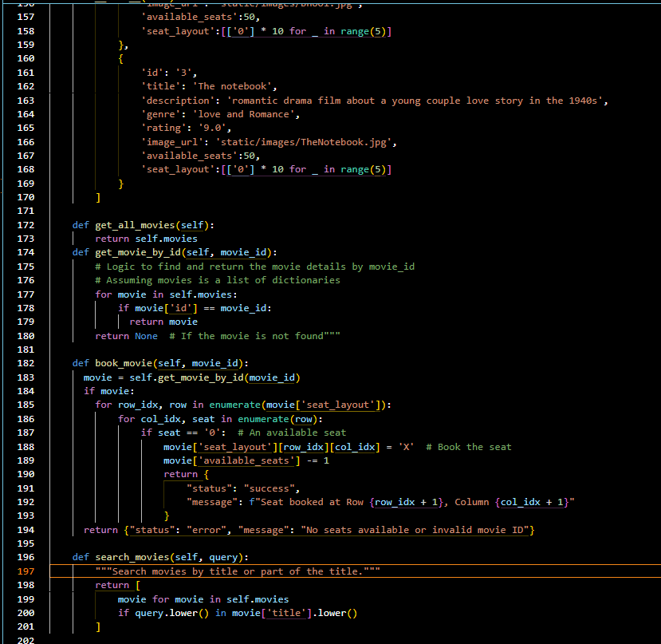

Conclusion & Summary
The Movie Booking System demonstrates how in-memory data structures can efficiently handle movie and user management without requiring a database. It offers features like user registration, authentication, movie search, and seat booking with a dynamic web interface. While suitable for small-scale use, it can be expanded with database integration and advanced features for larger systems. The system uses OOP principles and in-memory data management for simplicity and speed, combined with a modular approach for clean separation of functionalities. It is suitable for small-scale applications and demonstrates a scalable design methodology for future expansion

